Imp points

1.Java is a statically-typed programming language. It means, all [variables](https://www.javatpoint.com/java-variables) must be declared before its use. That is why we need to declare variable's type and name.

2.primitive. vs non primitive

1. **Size:**
   * Primitive data types have fixed sizes, which are generally smaller than non-primitive types.
   * Non-primitive data types have variable sizes depending on the data they reference.
2. **Default Values:**
   * Primitive data types have default values (e.g., **0** for **int**).
   * Non-primitive data types have a default value of **null** to signify that they don't refer to any object until explicitly initialized.

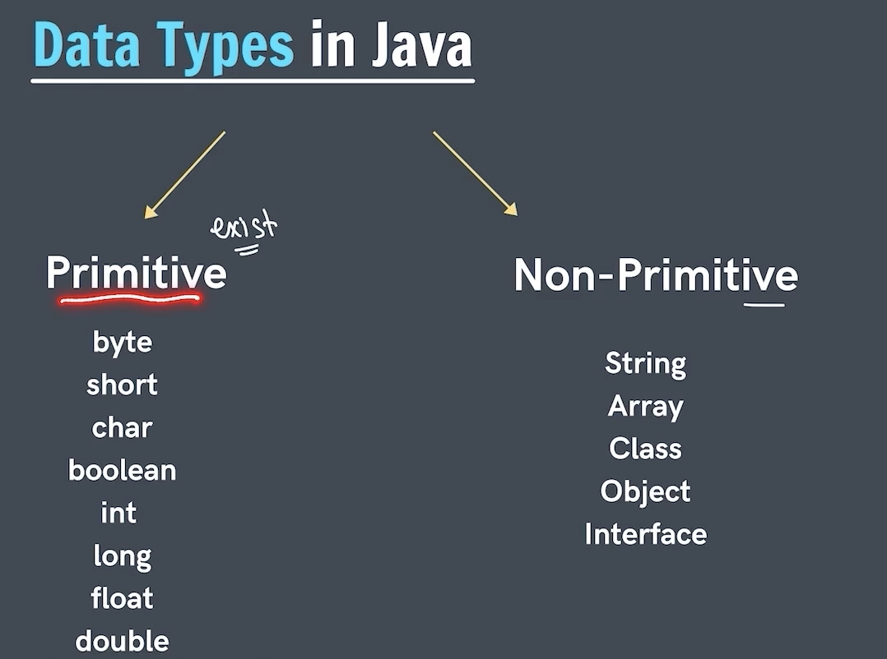

3.type conversion and type casting

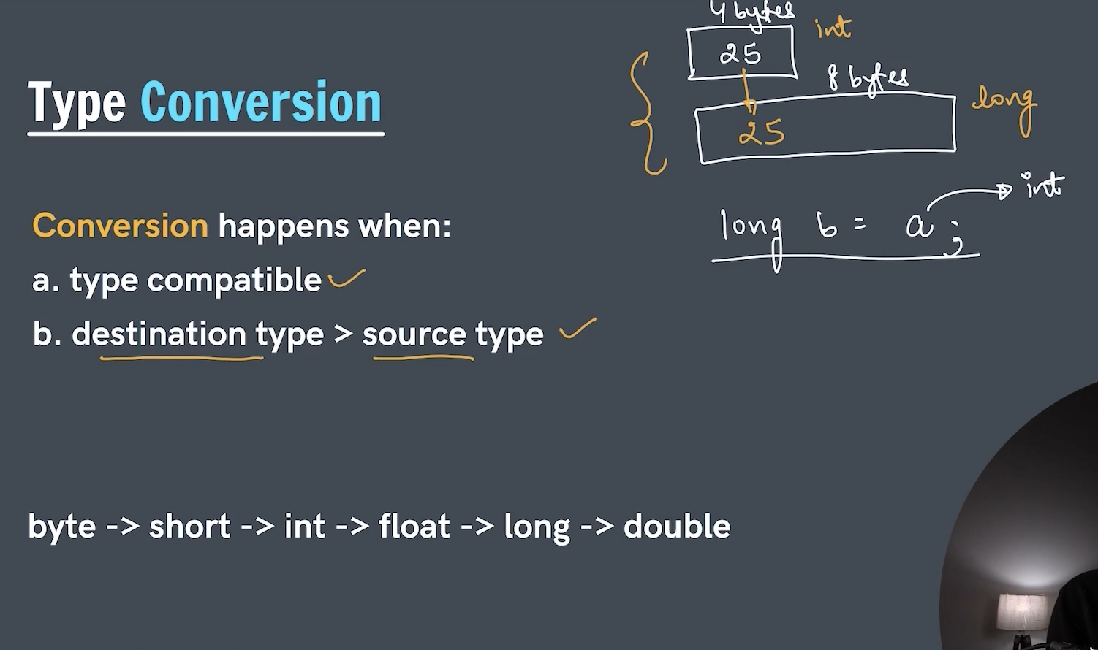

4.type promotion in expression

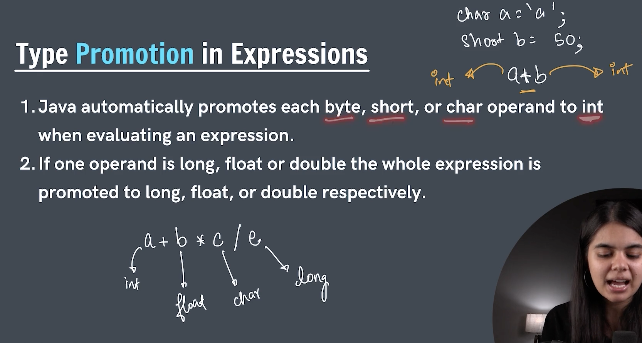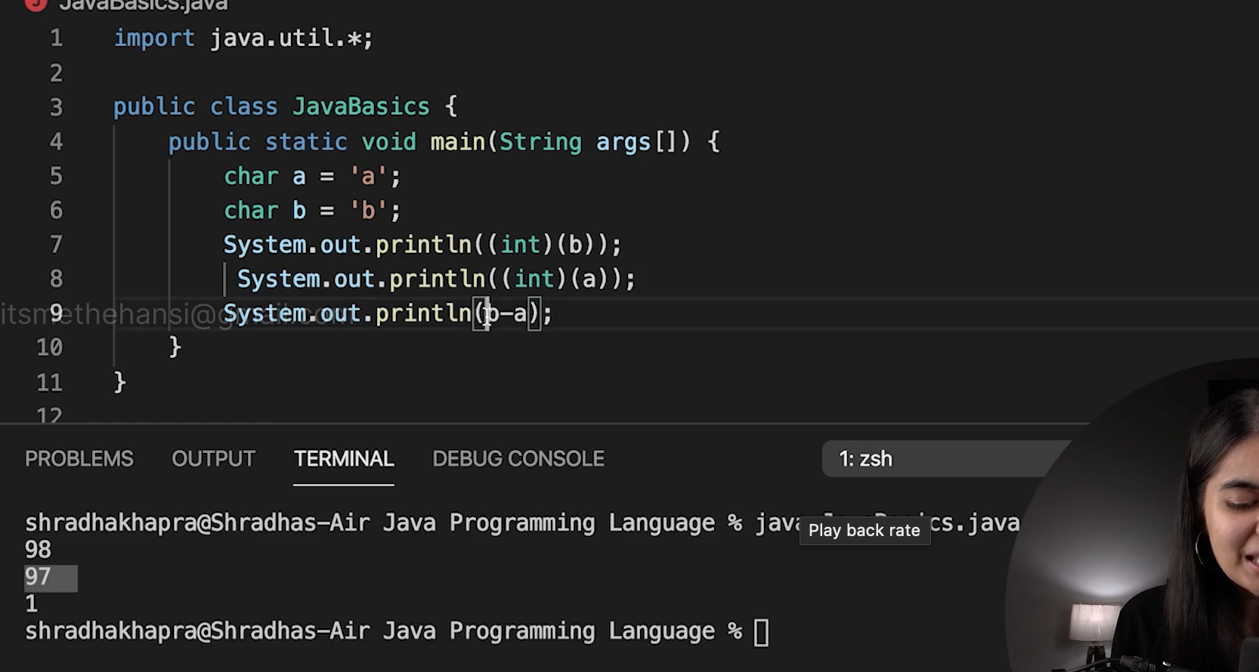

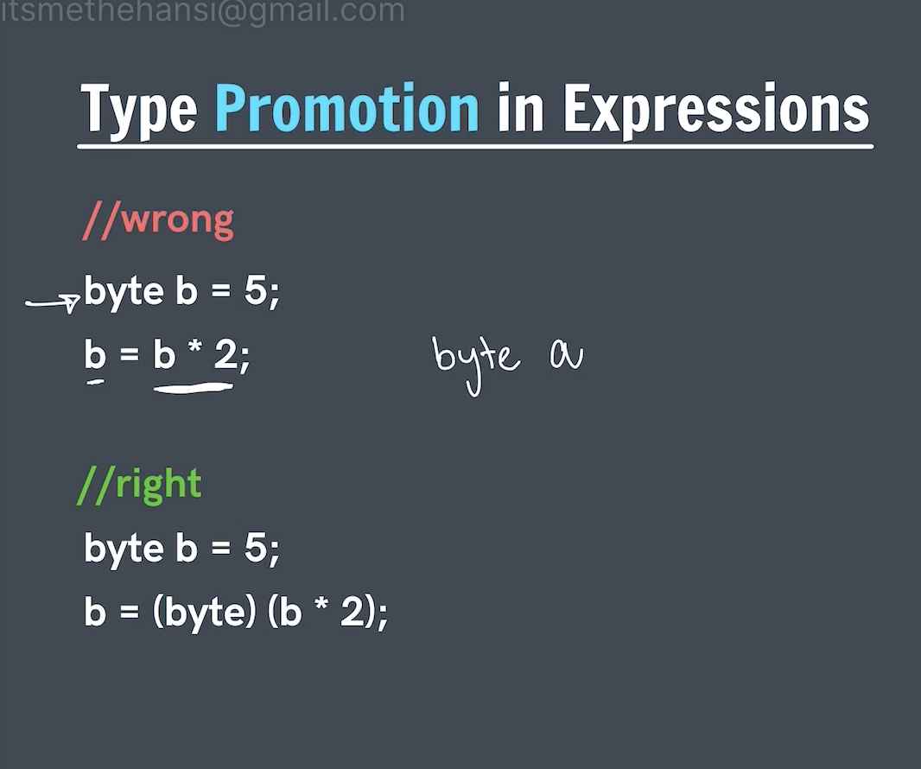

Imp:

Here as u see

Byte b=5;

b=b*2; //we can say that b value is 5 so 5*2=10 which is In range -128 to 127 but the thing is that in java b*2 is treated as an expression the type promotion in expression come to role where byte,short,char are promoted to int so here b is byte which is converted to int so u cant store int directly in byte u need to type cast it to store

5.how code runs in java

